Chapter 3, Problem 43.

Use mesh analysis to find v_{ab} and i_{o} in the circuit in Fig. 3.89.

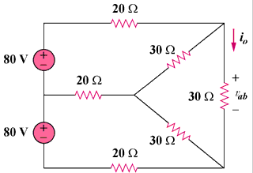

Figure 3.89
For Prob. 3.43.

